**Media documentation**

**Frontend**

* Register:

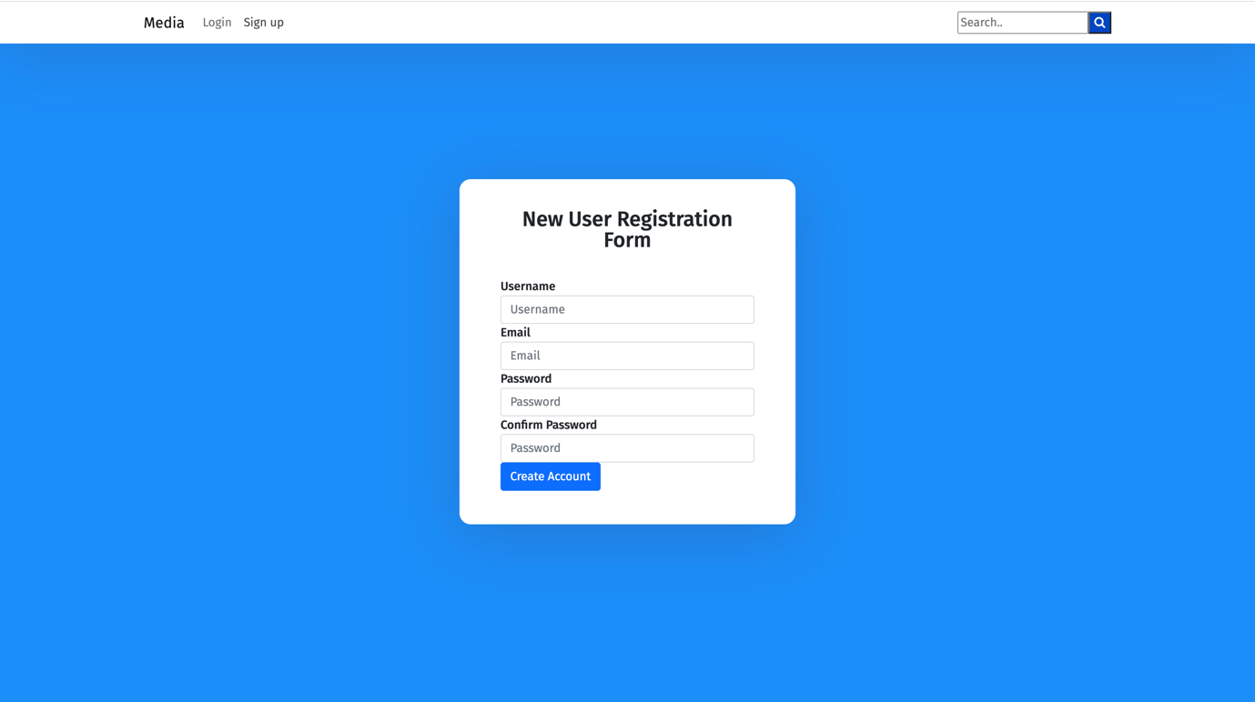

You can register into the platform using username, email and password

* Login

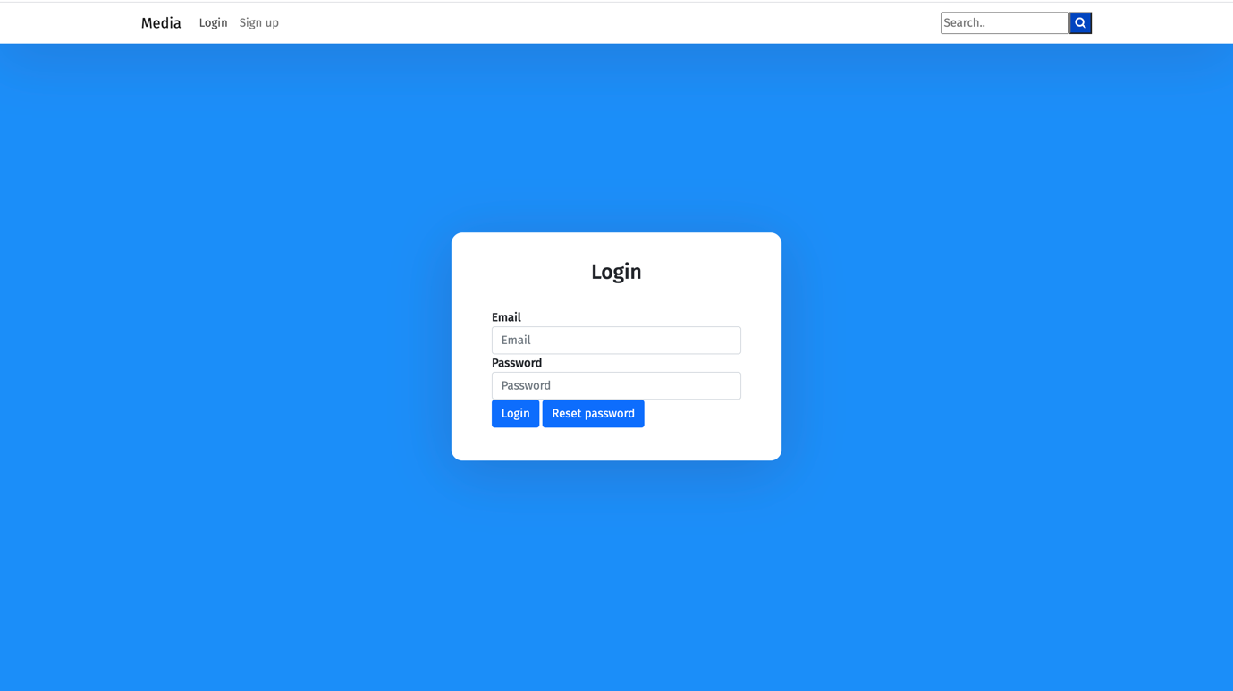

The login into the system is executed using email and password

* Browse articles

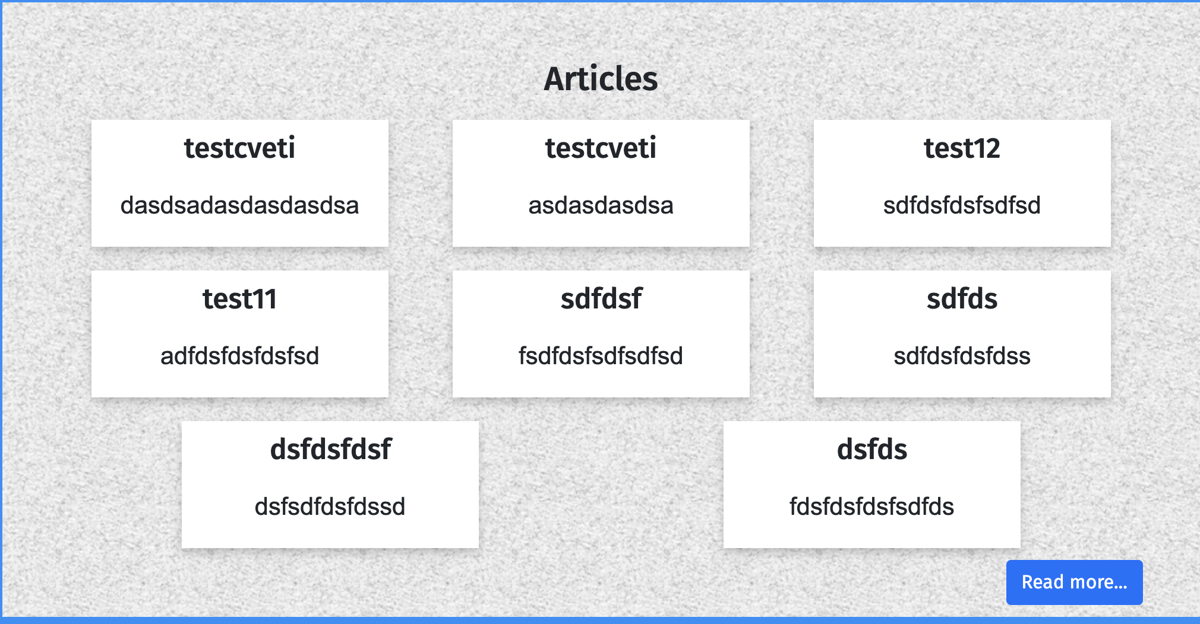

8 articles are displayed at the home page. You can view all articles by clicking “Read more”.

* Create article

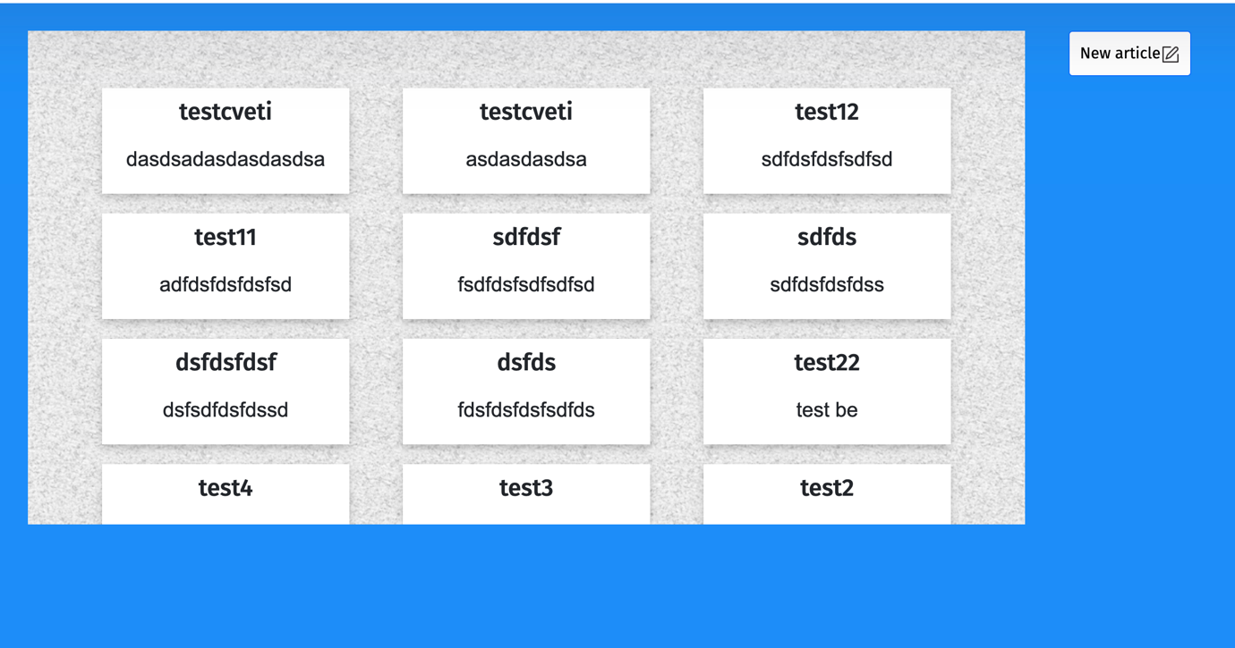

You can find a “New article” button after clicking “Read more” in the articles tab in the home page.

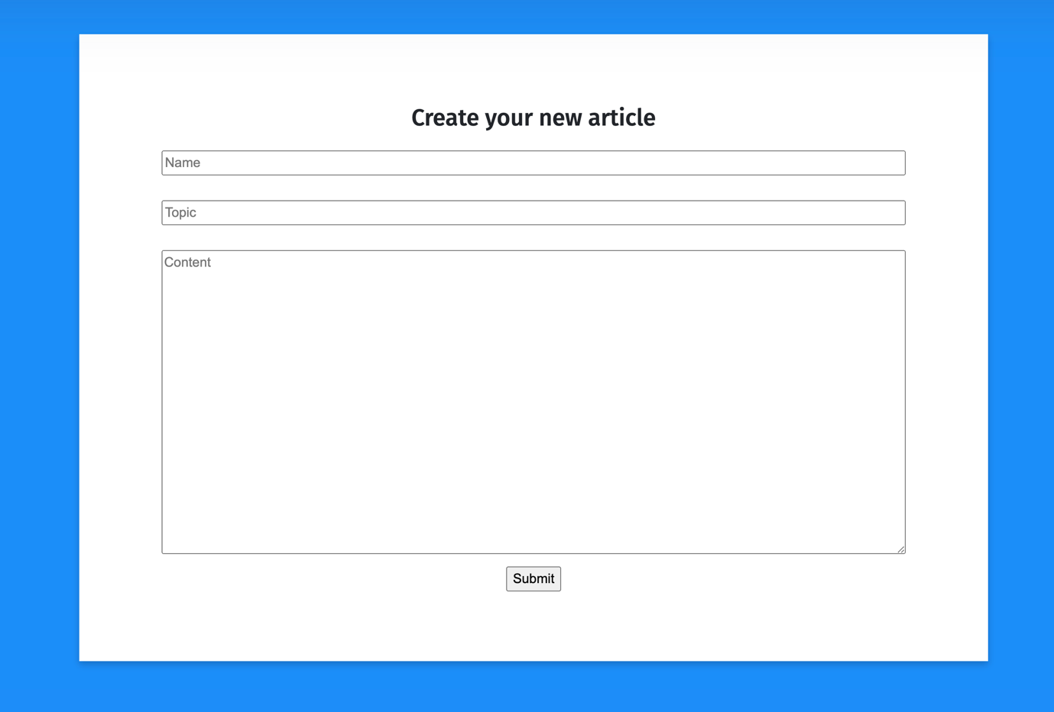

You can create a new article with given name, topic and content.

* Browse photo articles

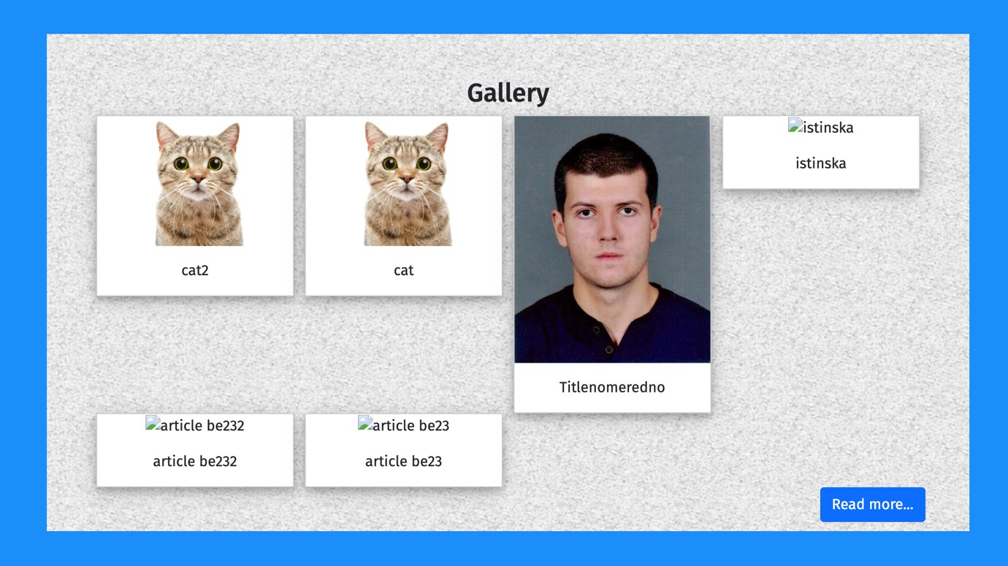

8 photo articles are displayed at the home page. You can view all photo articles by clicking “Read more”.

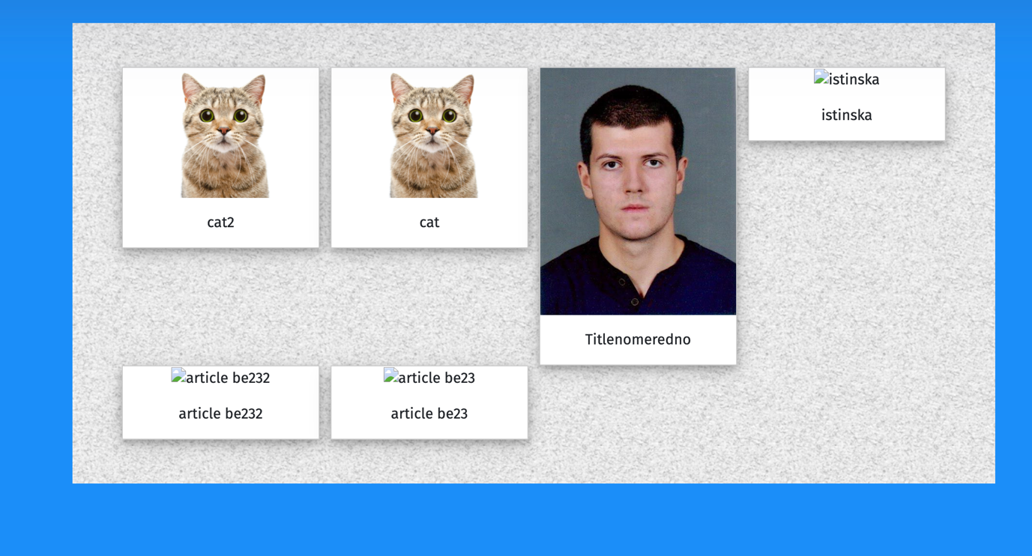

* Create photo article

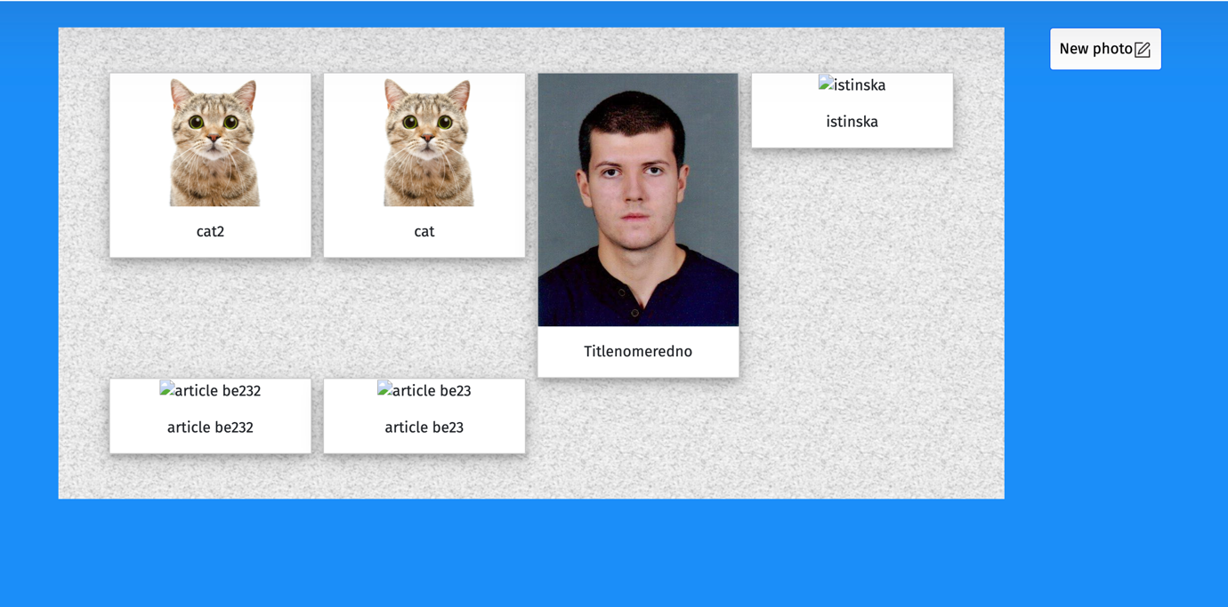

You can find a “New photo” button after clicking “Read more” in the photo articles tab in the home page.

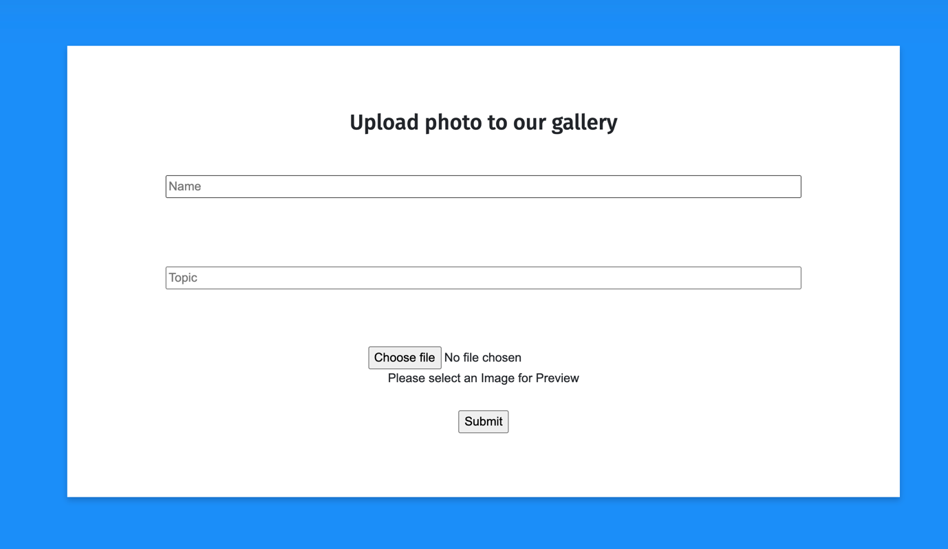

You can create a new photo article with a given name, topic and photo.

* Browse polls

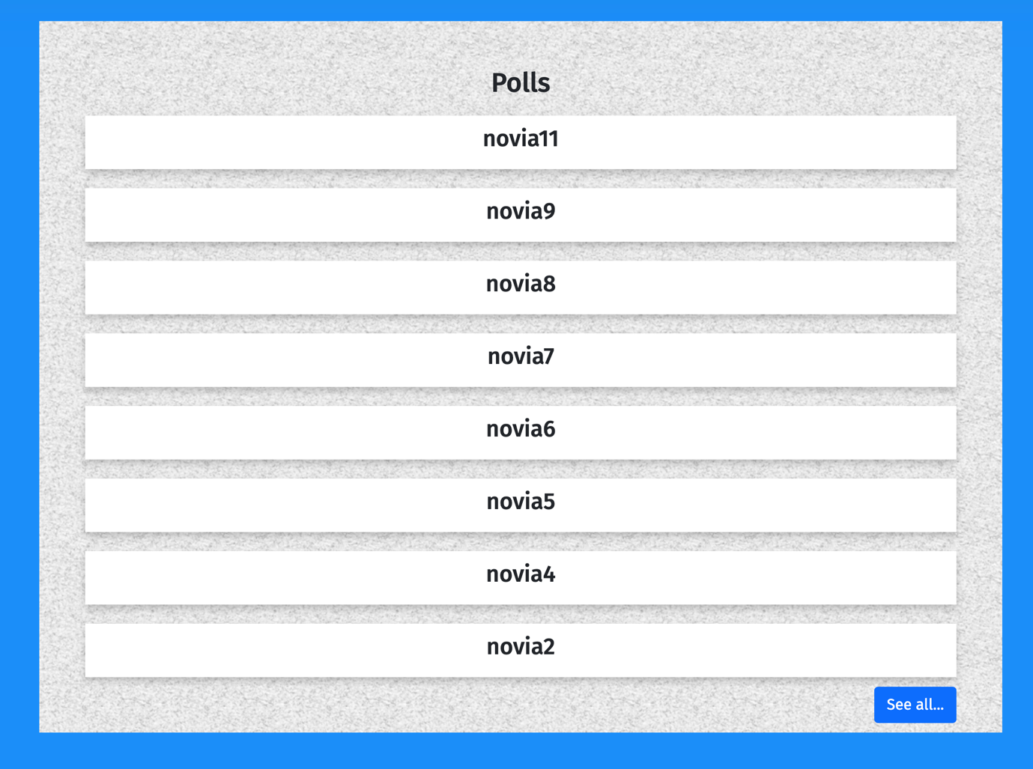

8 polls are displayed at the home page. You can view all polls by clicking “See all”.

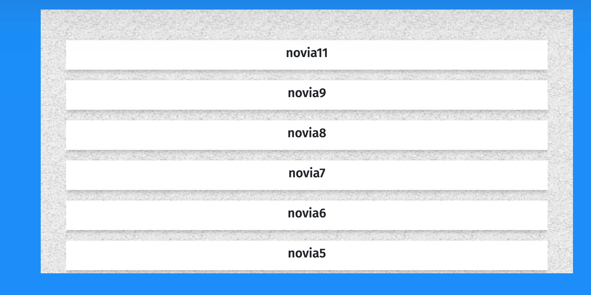

* Create poll

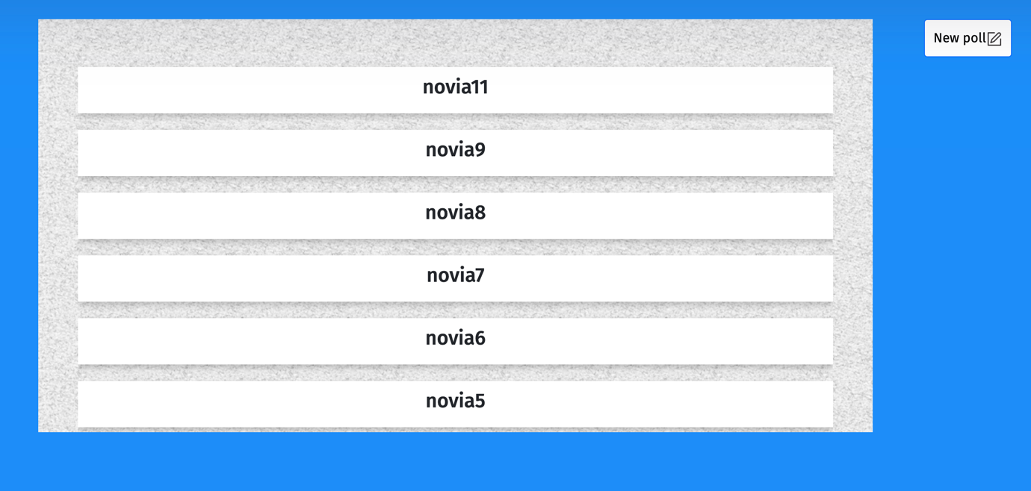

You can find a “New poll” button after clicking “See all” in the polls tab in the home page.

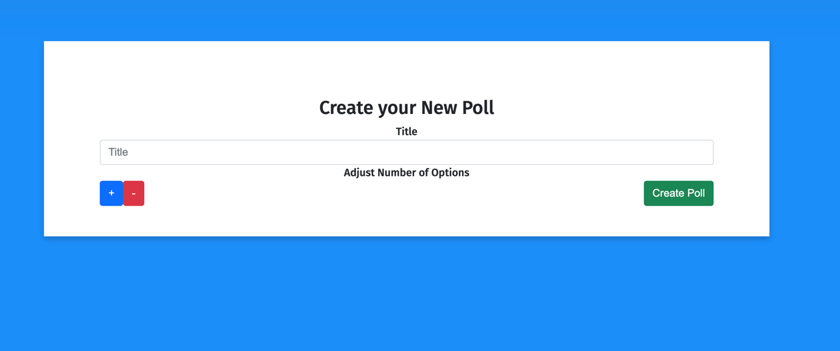

You can create a new poll with a given title and at least two options.

* Vote in poll

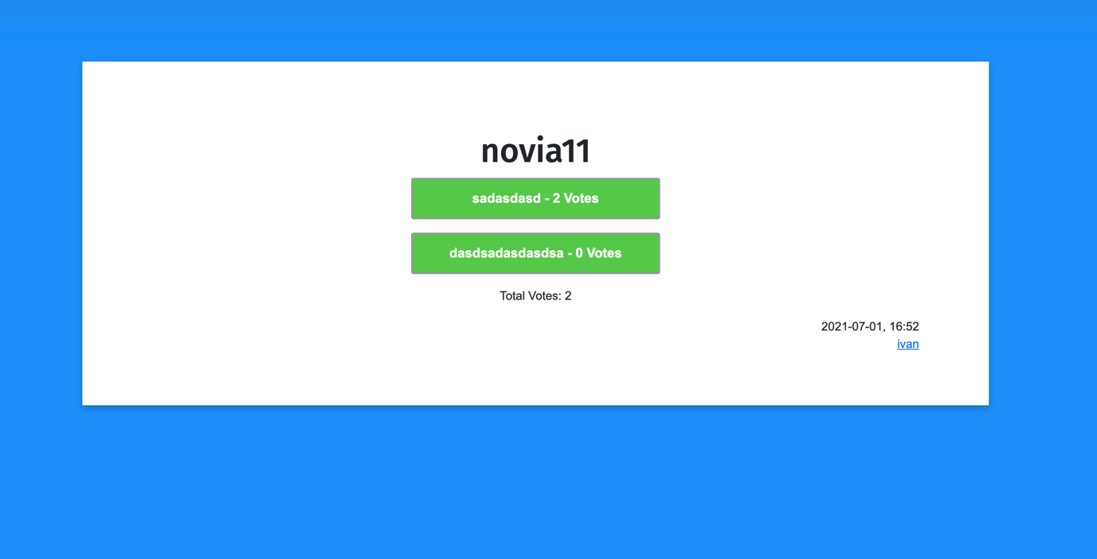

You can vote in existing polls.

* Browse events

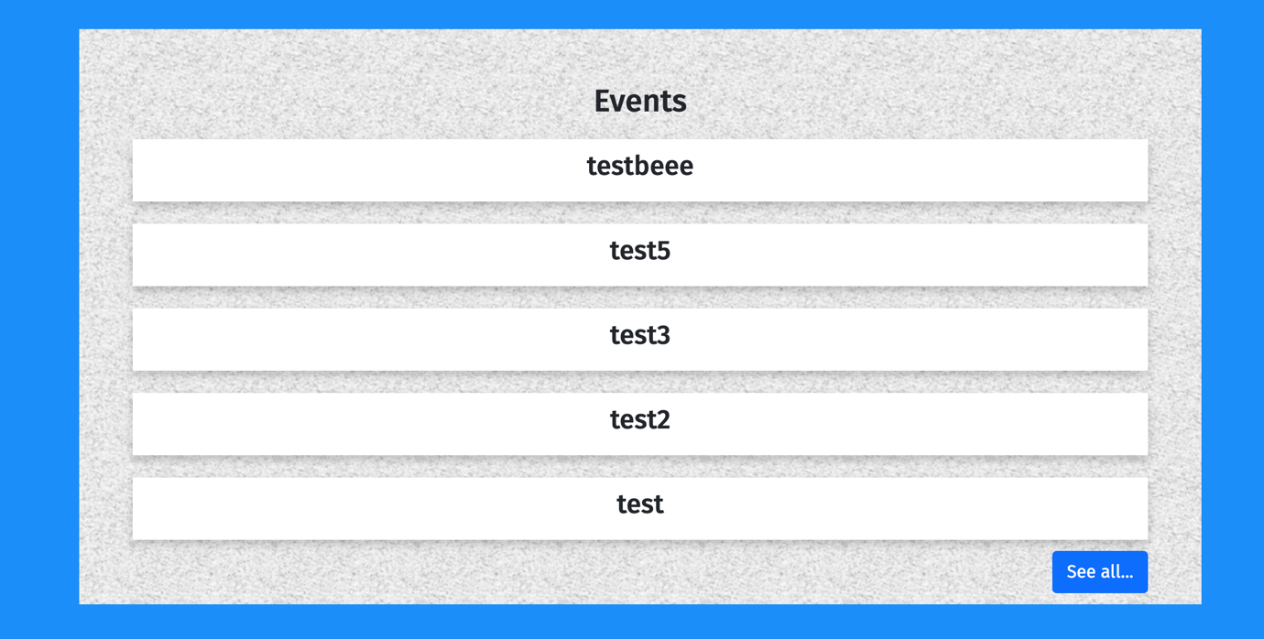

8 Events are displayed at the home page. You can view all events by clicking “See all”.

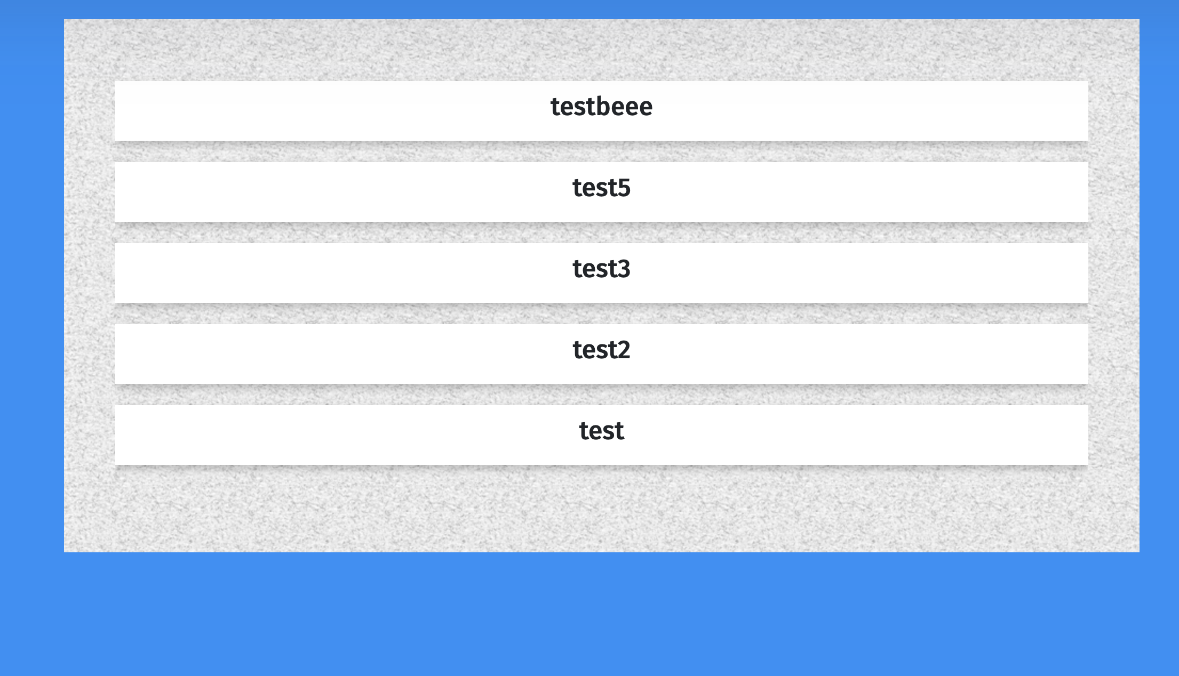

* Create event

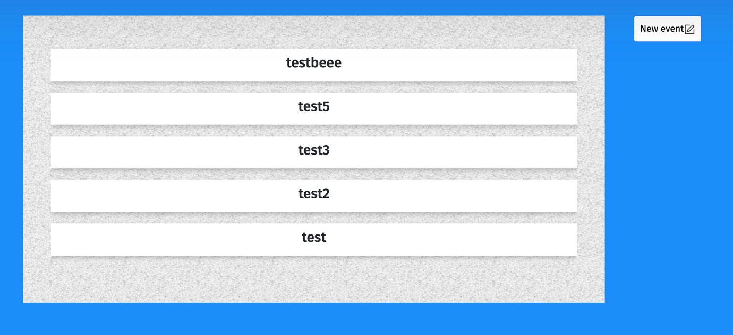

You can find a “New event” button after clicking “See all” in the events tab in the home page.

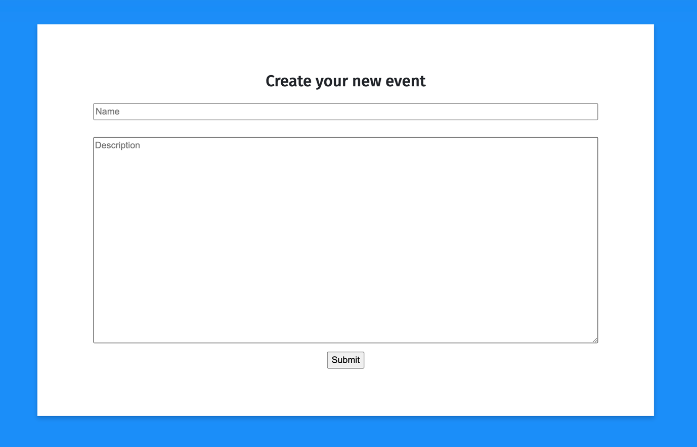

You can create a new event with a given name and description.

* Search resources

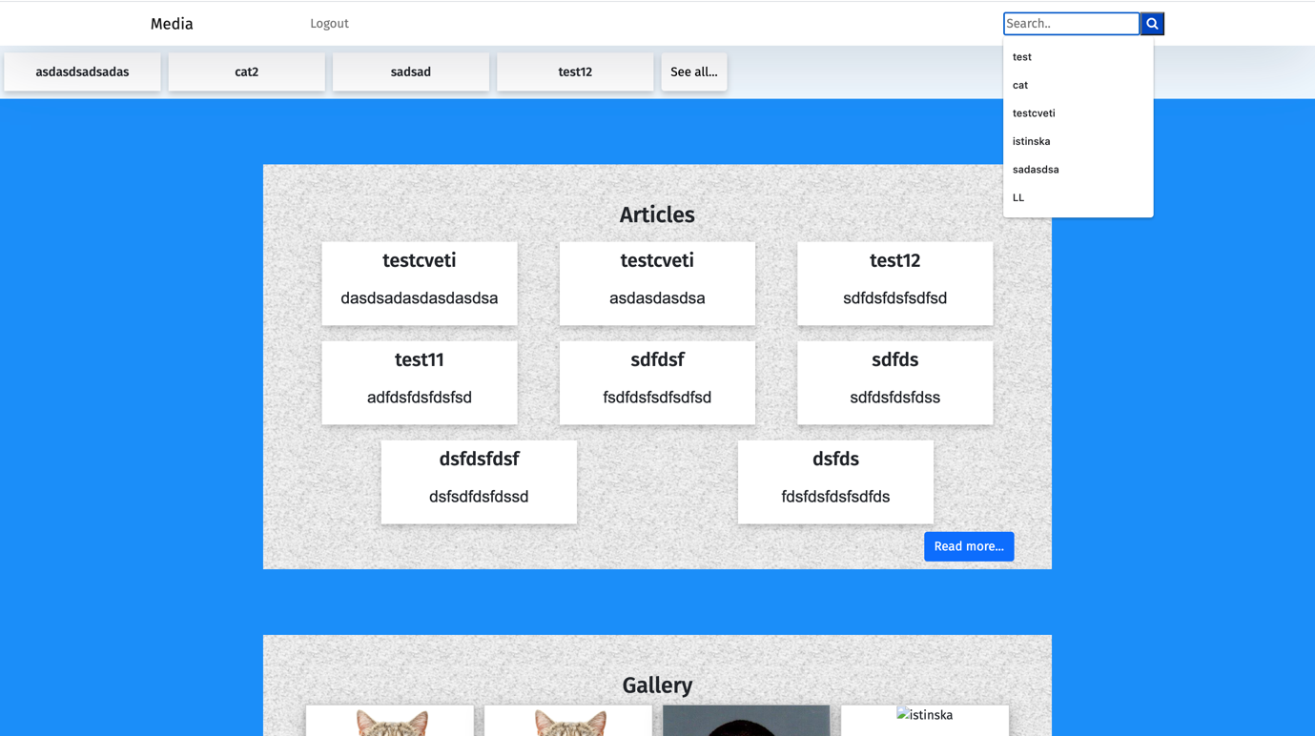

You can search for resources using the search bar at the upper right corner.

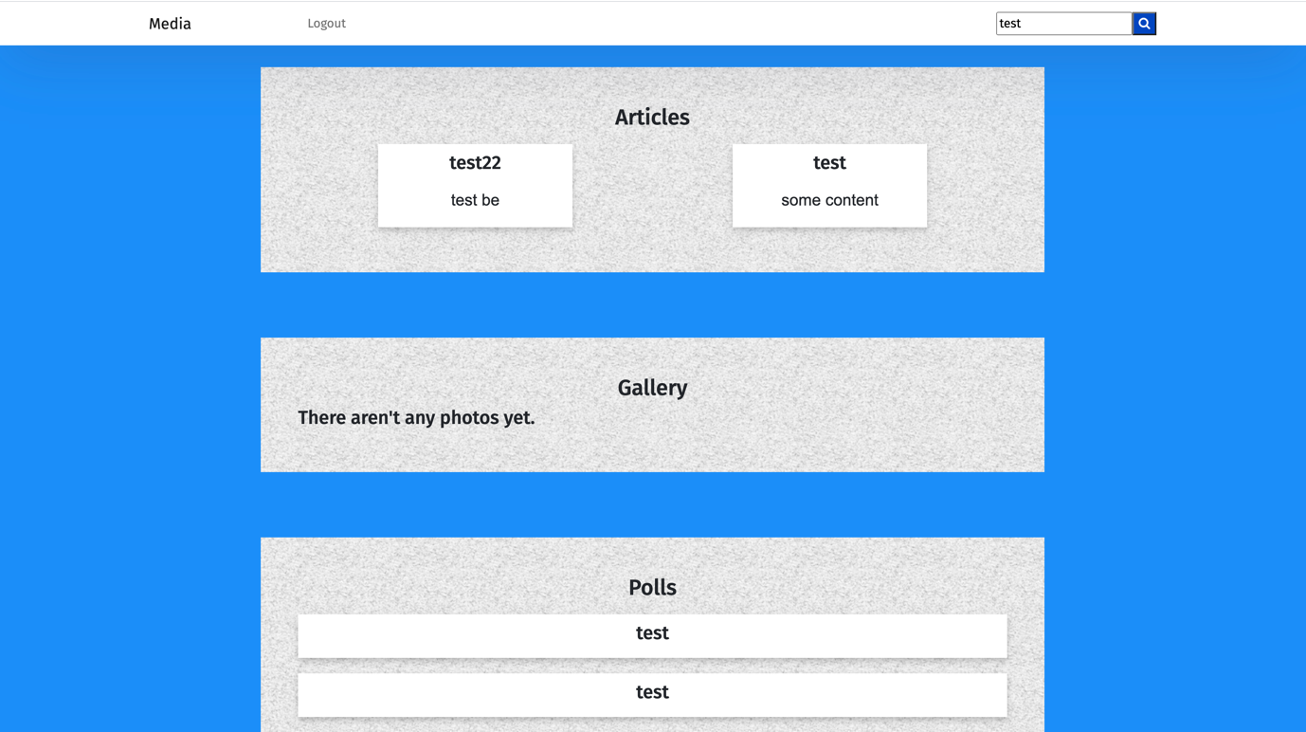

* Logout

You can logout at any time using the logout button.

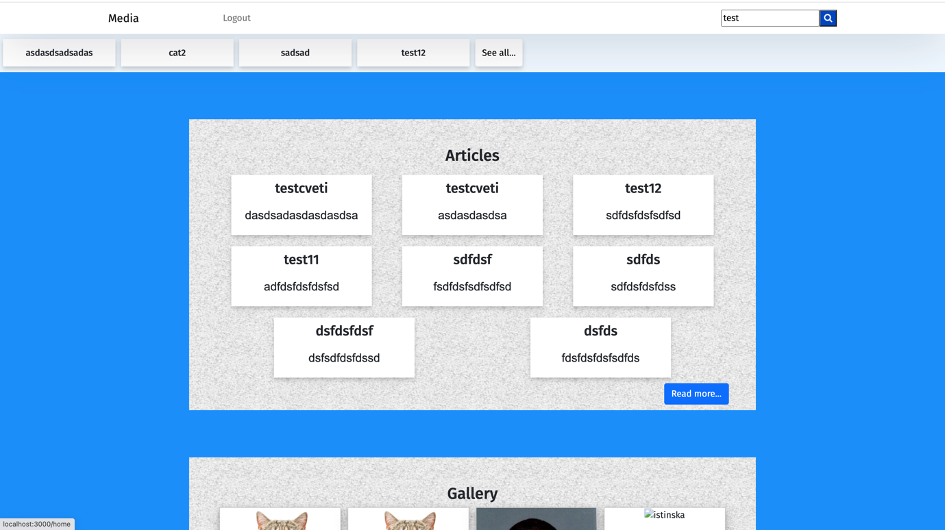

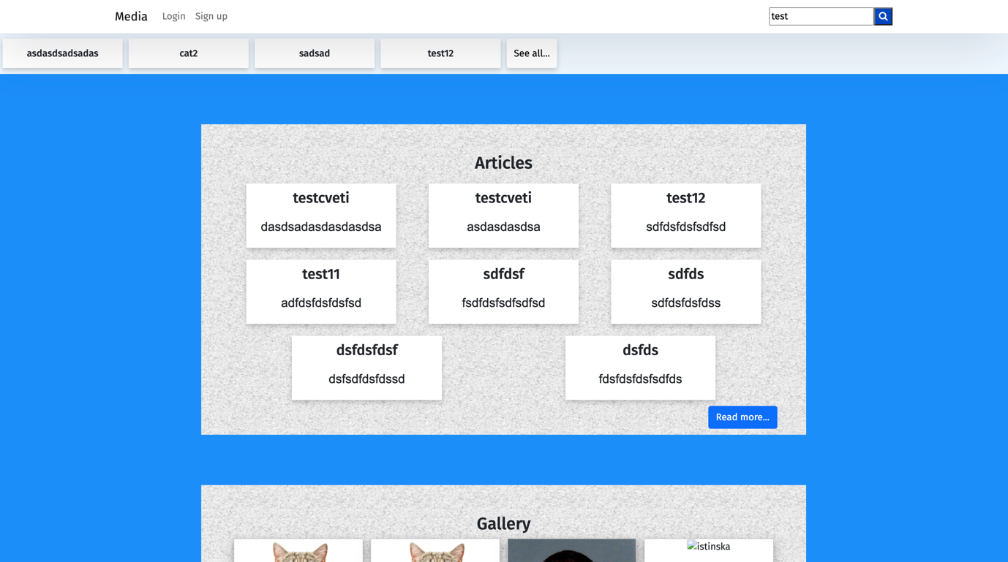

* Reset password

You can reset your password using the reset password button in the login page.

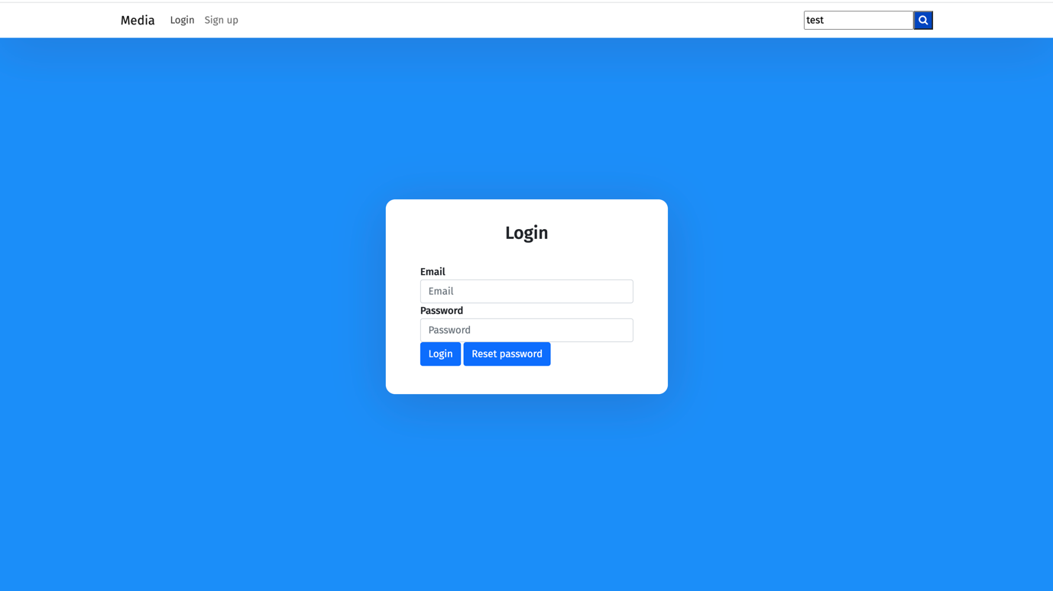

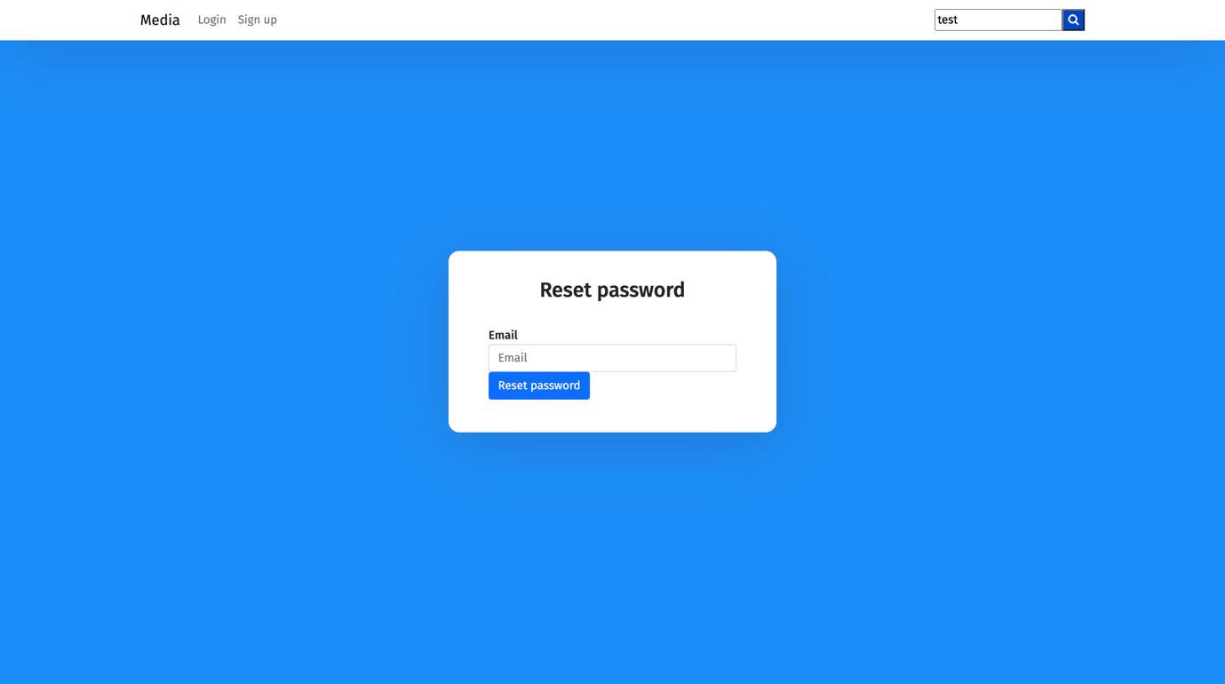

**Backend**

* Register

Endpoint:

Post {host}/api/users/register

Body:

{

"email": "test",

“name”: "test",

“password”: "test",

“password2”: "test",

}

* Reset password

Endpoint:

Post {host}/api/users/resetPassword

Body:

{

"email": "test"

}

* Login

Endpoint:

Post {host}/api/users/login

Body:

{

"email": "test",

"password": "test"

}

Returns jwt token used as authorization header in all modification operations:

{

"success": **true**,

"token": "test"

}

* Show all articles

Endpoint:

Get {host}/api/articles

* Create article

Endpoint:

Post {host}/api/articles

Body:

{

"name": "test",

"topic": "test",

"content": "test"

}

Headers:

Authorization: test

* Show all photo articles

Endpoint:

Get {host}/api/articles?isPhotoArticle=true

* Create photo article

Endpoint:

Post {host}/api/articles

Body:

{

"name": "test",

"topic": "test",

"content": "test",

“isPhotoArticle”: “true”

}

* Show all polls

Endpoint:

Get {host}/api/polls

* Create poll

Endpoint:

Post {host}/api/polls

Body:

{

"name": "test",

"answers": [“answer1”,”answer2”]

}

* Vote in poll

Endpoint:

Put {host}/api/polls/:id

Body:

{

"answer": “test”

}

* Show all events

Endpoint:

Get {host}/api/events

* Create event

Endpoint:

Post {host}/api/events

Body:

{

"name": "test",

"description": “test”

}